**Agent Uninstall**

This article has been updated to support v11.7.8 of Goliath Performance Monitor.

This article will guide you through the process of uninstalling the Goliath Intelligent Agent. Please see the Article Contents below for the appropriate instructions.

**Article Contents**

1. [Windows Agent Uninstall Instructions](https://support.goliathtechnologies.com/hc/en-us/articles/360025106494-Agent-Uninstall#h_666346fc-86f4-4c66-acf2-3161848a09d5)
   1. [Automated Uninstall via the Goliath Console](https://support.goliathtechnologies.com/hc/en-us/articles/360025106494-Agent-Uninstall#h_f7da27c6-29d6-4a8c-8346-5cd6235f3514)
   2. [Manual Uninstall via Control Panel](https://support.goliathtechnologies.com/hc/en-us/articles/360025106494-Agent-Uninstall#h_6622a2a6-0a47-4552-a9a2-f6977e4ce727)
   3. [Manual Uninstall via Command Prompt](https://support.goliathtechnologies.com/hc/en-us/articles/360025106494-Agent-Uninstall#h_0bd5f365-dbba-4daf-8930-e88fcad1e4e6)
2. [Gold Images/Master Images/Templates Agent Uninstall Instructions](https://support.goliathtechnologies.com/hc/en-us/articles/360025106494-Agent-Uninstall#h_95a2ed55-1fff-47d2-92eb-c89ecc5eb4ca)
   1. [Manual Uninstall via the Control Panel](https://support.goliathtechnologies.com/hc/en-us/articles/360025106494-Agent-Uninstall#h_98618bdf-28bc-40b4-abf7-1d5792bea89b)
   2. [Manual Uninstall via Command Prompt](https://support.goliathtechnologies.com/hc/en-us/articles/360025106494-Agent-Uninstall#h_641e2c36-67c2-44d9-9d05-0365d7faf2c0)
3. [Linux/Unix Agent Uninstall Instructions](https://support.goliathtechnologies.com/hc/en-us/articles/360025106494-Agent-Uninstall#h_eb668f04-d7ca-4189-9e78-7048ef2b49d0)
4. [Appendix](https://support.goliathtechnologies.com/hc/en-us/articles/360025106494-Agent-Uninstall#h_8eba582e-db31-4d67-a222-0c27c34afcbd)
   1. [Determining Agent Connectivity in Goliath Performance Monitor](https://support.goliathtechnologies.com/hc/en-us/articles/360025106494-Agent-Uninstall#h_fb7ac7ee-7d1a-4c20-9a40-16ddb3f7020f)

**Windows Agent Uninstall Instructions**

**Automated Uninstall via the Goliath Console**

Below are instructions for uninstalling the Intelligent Agent from a Windows machines via the Goliath console. Please note, the agent must be connected to the Goliath Performance Monitor server in order to successfully uninstall. If you are unsure of how to confirm the agent connectivity, please see the [Appendix](https://support.goliathtechnologies.com/hc/en-us/articles/360025106494-Agent-Uninstall#h_8eba582e-db31-4d67-a222-0c27c34afcbd).

1. Open Goliath Performance Monitor and select the **‘Configure’**tab and then the **‘Inventory’**submenu
2. Select each Windows machine that you would like to uninstall the agent on via the checkbox options on the left hand side
3. At the bottom of the page, click the **‘Delete’** button
   1. Depending on the number of machines that the agent is uninstalling on, it may take 2 – 10 minutes to complete
4. When the uninstall is complete, the selected machines will no longer appear on the Inventory screen
5. Log into each machine and delete the MonitorIT folder located by default in the ‘C:\Program Files’ parent folder if desired

**Manual Uninstall via the Control Panel**

Below are instructions for uninstalling the Intelligent Agent from a Windows machines using Control Panel. **Please note, this option is only applicable for machines where the agent was manually installed via the installer. This option will not be application for remote deployments of the agent and command line installs.**

1. Sign in to the Windows machine in which you would like to uninstall the agent
2. Open Control Panel, and navigate to **‘Programs and Features’**
3. Find and select **‘MonitorIT Agent’** or **'Goliath Performance Monitor Agent'**in the list
4. Click **‘Uninstall’**at the top of the page, this will bring open then uninstall executable
5. To begin the uninstall, click **‘Next’**
6. When the uninstall is finished select **‘Finish’**
7. Delete the MonitorIT folder located by default in the **‘C:\Program Files’** parent folder

**Manual Uninstall via Command Prompt**

1. Sign in to the Windows machine in which you would like to uninstall the agent
2. Open Command Prompt as admin
3. Navigate to the agent install directory of the Intelligent agent. Below is an example using the default location.

cd “C:\Program Files\MonitorIT”

1. Once within the agent install directory, type the below command to uninstall the agent

Agentservice.exe -u

1. Type exit and hit the enter key to exit Command Prompt
2. Delete the MonitorIT folder

**Gold Images/Master Images/Templates Uninstall Instructions**

**Manual Uninstall via the Control Panel**

Below are instructions for uninstalling the Intelligent Agent in the Gold Image/Master Image/Template using Control Panel.

1. Sign in to the Windows machine in which you would like to uninstall the agent
2. Open Control Panel, and navigate to **‘Programs and Features’**
3. Find and select **‘MonitorIT Agent’ or 'Goliath Performance Monitor Agent'**in the list
4. Click **‘Uninstall’**at the top of the page, this will bring open then uninstall executable
5. To begin the uninstall, click **‘Next’**
6. When the uninstall is finished select **‘Finish’**
7. Delete the MonitorIT folder located by default in the **‘C:\Program Files’**parent folder

**Manual Uninstall via Command Prompt**

1. Sign in to the Windows machine in which you would like to uninstall the agent
2. Open Command Prompt as admin
3. Navigate to the agent install directory of the Intelligent agent. Below is an example using the default location.

cd “C:\Program Files\MonitorIT”

1. Once within the agent install directory, type the below command to uninstall the agent

Agentservice.exe -u

1. Type exit and hit the enter key to exit Command Prompt
2. Delete the MonitorIT folder

**Linux/Unix Agent Uninstall Instructions**

1. To stop the Agent once it has been running, execute the following command from the directory where you have copied the files:

/**FullyQualifiedPathToTheInstalledJava**/bin/java -cp MonitorITAgent.jar com.breakoutsoft.agent.Agent –shutdown

Again, using the earlier example where the java program is located at ‘/usr/bin’ and MonitorIT is located in the ‘/opt/MonitorIT’ directory, perform the following steps:

a. Go to the MonitorIT directory:

cd /opt/MonitorIT

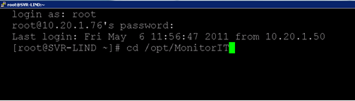

b. Execute the command:

/usr/bin/java –cp MonitorITAgent.jar com.breakoutsoft.agent.Agent –shutdown

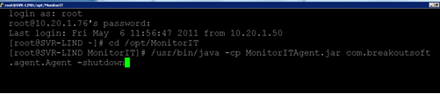

1. Then delete the directory where the Agent files are installed and remember to remove the command-line from the 'local' file or equivalent file used when installing the agent.

         a. Go to the directory where the files are located, if the agent files are located in a directory called MonitorIT within /opt then:

cd /opt

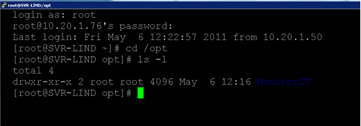

       b. Execute the command to delete the directory:

rm–r MonitorIT

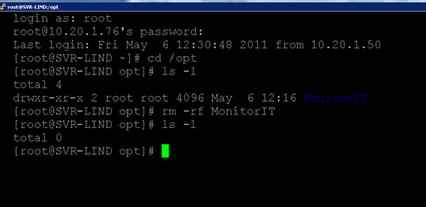

       c. Remove the startup scripts (varies by operating system)from d

       d. Remove the agent from the Goliath console by going to **‘Configure>Inventory’** selecting the    server, and choosing delete at the bottom of the page.  Otherwise, Goliath will report the agent as **‘down’** or **‘unavailable’**

**Appendix**

**Determining Agent Connectivity in Goliath Performance Monitor**

This section will review how to identify if the Intelligent Agent is connected to the server or not.

1. Open the Goliath Performance Monitor console
2. Navigate to the **‘Configure’**tab and then the **‘Inventory’**submenu
3. The Inventory display lists all of the machines and devices that are being monitoring. The **‘Stat’**column designates the status of the agent.
4. If the **‘Stat’**column has a **green**box for the inventory item, the agent is connected to Goliath Performance Monitor.
5. If the **‘Stat’**column has a **red**box for the inventory item, the agent is not connected to Goliath Performance Monitor.
6. If the **‘Stat’**column does not have a box for the inventory item, there is no agent installed.